**Enchanted Ireland & Scotland Tour**

#### **Aug 11. Depart for Newark International Airport**

#### **Aug 12. Arrive Dublin – City Tour**

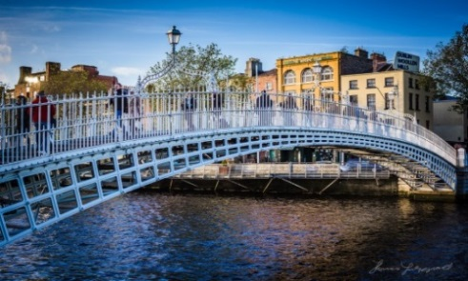Following arrival at Dublin Airport, you will be met by your Tour Guide and escorted to your awaiting motorcoach. This morning you will enjoy a tour of **Dublin City**, founded as a **Viking settlement** and has been **home to the Irish Parliament** since the creation of the Irish Free State in 1922. On your tour, you will see the **Georgian Squares** with their 18th Century houses, **St. Patrick’s Cathedral**, **the Phoenix Park** (biggest town park in Europe), statue filled **O’Connell Street** and the fashionable **Grafton Street**. You will also see **Trinity College** which houses the **Book of Kells**. No visit to Dublin would be complete without a visit to the **Guinness Brewery** **founded in 1759** by Arthur Guinness. Here you will enjoy a guided tour which concludes with a leisurely **pint of Guinness** in the **360-degree roof top** bar while enjoying some spectacular views of Dublin City. This afternoon you will check into your hotel for an overnight stay. **Later you will regroup with your fellow travelers and enjoy a welcome dinner. Overnight: The Camden Court Hotel. Dublin. (D)**

#### **Aug 13. National Stud Farm – Rock of Cashel – Kinsale**

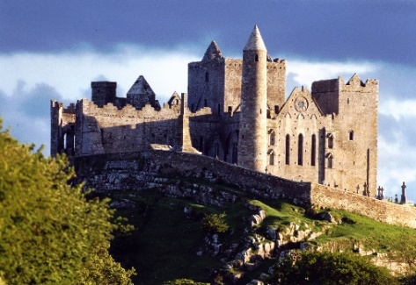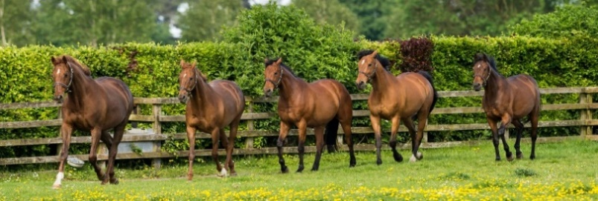This morning you bid farewell to Dublin and travel south to County Kildare - the center of Ireland’s horse breeding industry where you will enjoy a guided tour of the **Irish National Stud Farm.** Since it bred its first winner **MINORU** in 1909, the stud farm at Tully has continued to produce many famous race horses.Also on the grounds of the Stud Farm are **The** **Japanese Gardens** renowned for their symbolism of “The Life of Man” and the recently opened **St. Fiacre commemorative garden**. From here you travel to **Cashel** where you will take a guided tour of the amazing **Rock of Cashel**. This was the seat of the Kings of Munster from 370 – 1101 and has early associations with **St. Patrick**. The group of medieval buildings includes a **12th century Round Tower, a 13th century Gothic Cathedral, a 15th century High Cross and Romanesque Chapel.** You continue to **Kinsale, a** **historic fishing town** on the southern coastline of County Cork. It has some old Cobble Stone Streets and many interesting shops and pubs. It is renowned for its restaurants and is known as the gourmet capital of Ireland. **This evening you will enjoy dinner in your hotel. Overnight: Actons Hotel. Kinsale (B, D)**

#### **Aug 14. Blarney Castle**

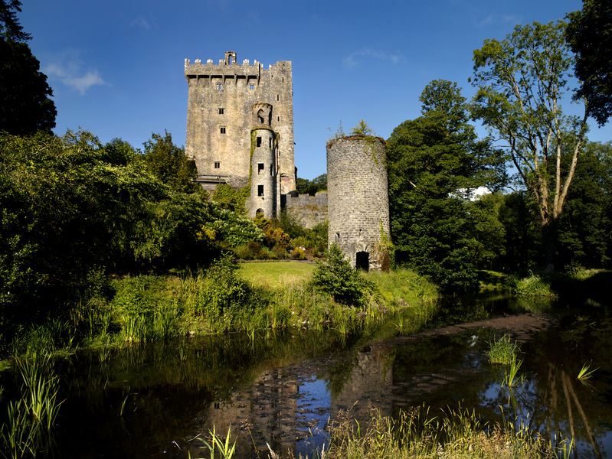This morning you travel to Blarney where you will visit **Blarney Castle and Gardens.** The castle was **built in 1446** and today you will have an opportunity to climb the spiral stairs to the top of the castle and kiss the famous **Blarney Stone** said to bestow the gift of eloquence on those who dare. As you make your way through the castle grounds, you can also visit the **Castle Gardens** and **Rock Close**. This will be followed by some free time to visit **The** **Blarney Woollen Mills** which carries a wide range of sweaters, tweeds, china and crystal. On returning to Kinsale, the remainder of the afternoon is free to enjoy browsing in its many shops, enjoy Kinsale's harbour and observe the marina activity. **Overnight: The Actons Hotel. Kinsale (B)**

#### **Aug 15. West Cork – Mizen Head – Kenmare – Killarney**

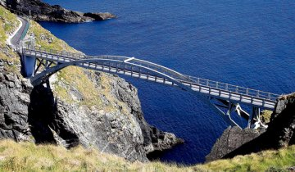This morning you depart Kinsale and travel along the southern coastline to Skibbereen. You continue to Ballydehob and from here to **Mizen Head** - **the** **most southerly point of Ireland**. Here you will visit the award winning **Maritime Museum** **and Heritage Attraction.** You can also take a ten-minute walk along the path, down the 99 steps and across the **Arched Bridge** over the crashing waves to the **Lighthouse**. Following this adventure, you will travel up the coast via lovely lazy towns & villages to **Kenmare,** an example of one of Ireland's few planned towns. Kenmare and its Gaelic name Neidin (Little nest) so named because of its fine setting nestling as it does among the mountains of Cork and Kerry. You continue to Killarney taking in a **20-mile stretch of the famous Ring of Kerry for a two night stay. This evening you will enjoy dinner in your hotel. Overnight: The Brehon Hotel. Killarney. (B, D)**

#### **Aug 16. The Dingle Peninsula**

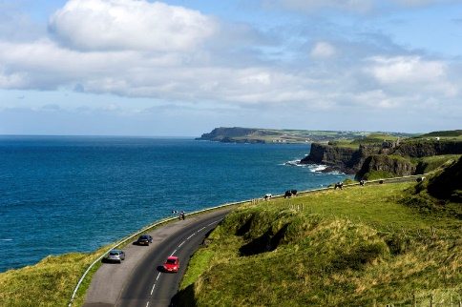Today you will enjoy the unspoiled beauty of the **Dingle Peninsula**, once cited as the most beautiful place on earth' by the **National Geographic**. You will stop at the **Brian de Staic studio in Dingle** which specializes in Celtic jewelry, handcrafted and engraved with ancient **Celtic symbols** and the letters of the ogham alphabet, an ancient Irish form of writing. As you continue around **Slea Head,** you will get some breathtaking views of the Atlantic coastline and see some **beehive huts** (early monastic settlements) **dating back over a thousand years.** Your tour will take you to the most westerly point of Ireland where you can view the **Blasket Islands** and see the locations for such films as **Ryan’s Daughter,** **Far and Away starring Tom Cruise** and **Nicole Kidman** and the more recently filmed **Star Wars - The Last Jedi.** You will have some free time in Dingle for lunch before returning to Killarney. **Overnight: The Brehon Hotel. Killarney. (B)**

#### **Aug 17. Tralee – Shannon Ferry – Cliffs of Moher – Galway**

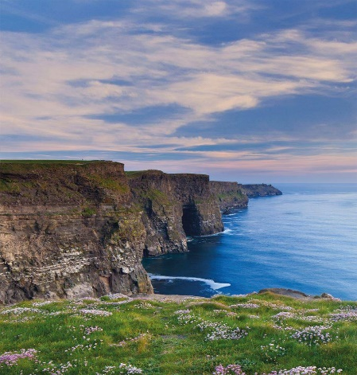This morning, you bid farewell to Killarney and travel to Tralee, capital town of County Kerry and famous for The **Rose of Tralee** Festival. You continue to Tarbert where you board the **Shannon Ferry** for a 25 minute sailing across the Shannon Estuary to Killimer. From here you take the coast road to the majestic **Cliffs of Moher** which rises to a height of 600 ft over the Atlantic Ocean. Following some free time to view the cliffs, your tour winds its way through **the lunar type landscape of the Burren,** from the Irish word 'bhoireann' meaning, 'a stony place' or 'a rocky place', which is a good description for this 350 sq. kilometers limestone plateau in North Clare. **You continue along the shores of** **Galway Bay** **to Galway City for an overnight stay**. **Later enjoy dinner in your hotel. Overnight: Hotel TBC. Galway.** **(B, D)**

#### **Aug 18. Galway – Sligo – Donegal**

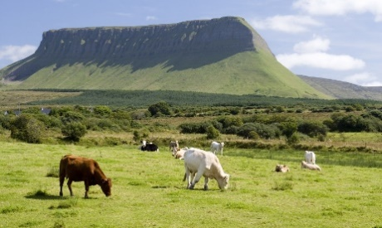This morning you depart Galway and travel northwards passing by the **Knock Shrine,** now an internationally recognized **Marian Shrine** with one and a half million pilgrims visiting annually.From here you travel to **Drumcliffe** in County Sligo - set against the striking backdrop of the **Benbulben Mountain.** It is best known as the final resting place of one of Ireland’s great poets **W.B. Yeats**.  Found in the churchyard, his grave is marked by a simple headstone with the inscription, "cast a cold eye on life, on death, horseman, pass by." You continue to **Belleek,** on the banks of the River Erne, most famous for the fine **Parian China** produced here at Belleek Pottery, the oldest pottery in Ireland. The china is valued by collectors from all over the world. Following a guided tour, you continue to Donegal for an overnight stay. **This evening you will enjoy dinner in your hotel. Overnight: The Mill Park Hotel. Donegal.** **(B, D)**

#### **Aug 19. Derry – Giant’s Causeway – Belfast**

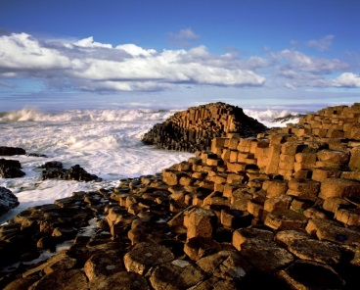This morning you travel to **Derry City** on the banks of the River Foyle. Derry City was **founded in 546AD** and still retains its **17C walls**. You will see the new **Derry Peace Bridge** over the River Foyle. This 235-metre-long pedestrian bridge opened in 2011 and bridges a 400-year-old physical and political gap between two sides of a once divided community. You continue to **Limavady** where you begin **the Antrim Coast Road Drive.** Of course, no visit to Northern Ireland would be complete without a visit to the **Giant’s Causeway** – a remarkable basaltic formation made of approximately **37,000 columns and ranked as one of the natural wonders of the world.** Your tour continues along the **Antrim Coast Road** with spectacular views of the northern coastline to **Belfast where you will check into the Titanic Hotel for an overnight stay. This evening enjoy dinner in your hotel. Overnight: The Titanic Hotel. Belfast. (B, D)**

#### **Aug 20. Belfast City – Scotland**

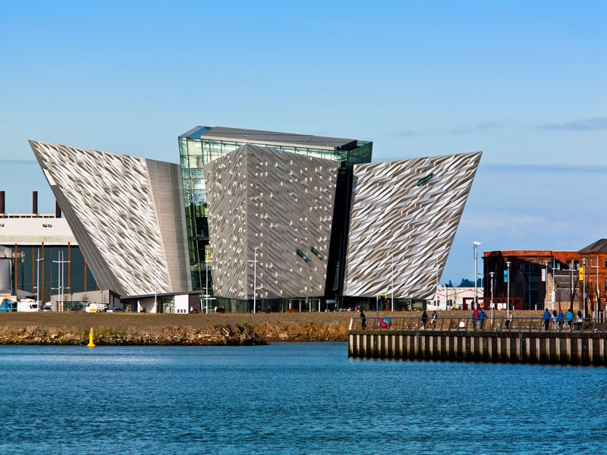This morning you will visit **Titanic Belfast**, a new state of the art visitor center whichwill take you through nine galleries, telling the story of RMS Titanic, from her conception in Belfast to her famous maiden voyage and tragic end. Later this morning you will travel to the port of Belfast and board the **ferry for a 2 ½ hour sailing across the North Atlantic** to **Cairnryan** in **Scotland.** On arriving in Scotland, you will travel to **Alloway** - the birthplace of **Robert Burns**, one of Scotland’s greatest poets. Following a stop at Burns Cottage, you continue to **Glasgow City for an overnight stay.** **This evening you will enjoy dinner in your hotel. Overnight: The Radisson Hotel. Glasgow**. **(B, D)**

#### **Aug 21. Glasgow City – Loch Lomond – Inverness**

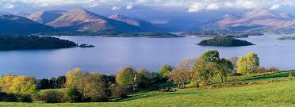This morning you enjoy a panorama tour **of Glasgow City,** often described as Britain’s finest Victorian City. On departing Glasgow, you will travel north along the banks of Loch Lomond, one of Scotland’s most beautiful lakes, into the **Scottish Highlands**. Surrounded by spectacular scenery you continue through the historic **Glen Coe** to **Fort William** on the shore of Loch Linnhe. From here, your tour winds its way around the foothills of Scotland’s highest mountain, **Ben Nevis** (4,406ft) to Fort Augustus. You continue along the banks of **Loch Ness**, keeping your camera ready for a view of the monster, to Drumnadrochit before arriving in **Inverness -** the capital of the highlands for an overnight stay. **Overnight: The Kingsmills Hotel. Inverness. (B, D)**

#### **Aug 22. Culloden – Pitlochry – St. Andrew’s – Edinburgh**

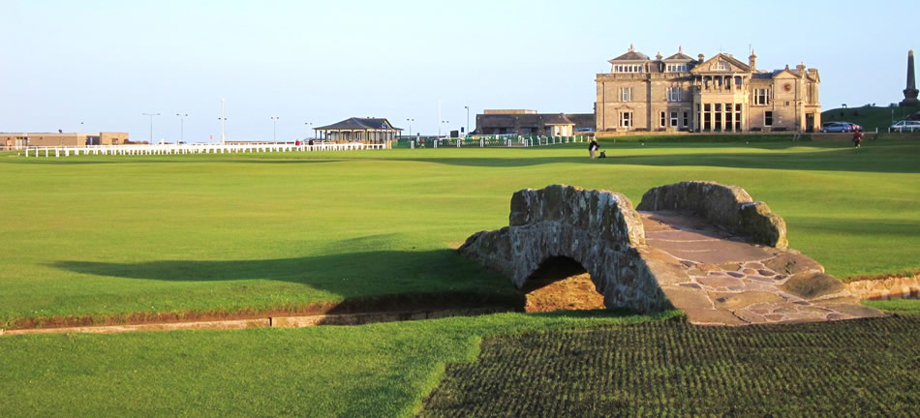This morning you depart Inverness and travel a short distance to **Culloden** for your first stop. The last major battle in Britain was fought here on April 16th 1746. This morning you can relive the drama with a visit to **Culloden Visitor Centre**. You then continue south through the scenic **Grampian Mountains** passing by **Blair Castle**, the ancient seat of the Dukes of Atholl and the only person in Britain allowed to keep a private army. You continue to **Dundee** before crossing the **Tay Bridge** to **St. Andrew’s.** Not only is St. Andrew’s famed as the home of golf, it is also an ancient ecclesiastical capital and **Scotland’s oldest university.** **You continue south traveling over the Forth Road Bridge to the historic Edinburgh City for a two-night stay. This evening you will enjoy dinner in your hotel. Overnight:** **The Radisson Hotel. Edinburgh. (B, D)**

#### **Aug 23. Edinburgh City Tour – Edinburgh Military Tattoo**

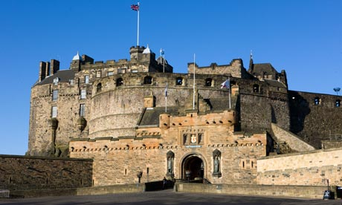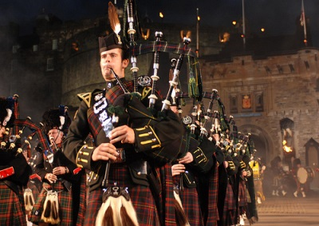This morning a tour of **Edinburgh City** awaits you. You will travel down **Princess Street** andthe **historic Royal Mile** before **visiting the Palace of Holyrood House - the official Scottish residence of her Majesty the Queen.** Hear the tales of some truly intriguing characters - **the Bodysnatchers,** **Dr. Jekyll and Mr. Hyde and Greyfriars Bobby.** You willvisit the majestic **Edinburgh Castle** and enjoy the breathtaking views of the city from the castle ramparts. You will have some free time before heading to Edinburgh Castle for the **Royal Edinburgh Military Tattoo**. This is Scotland’s most popular event and attracts international entertainers and audiences from all over the world. **Overnight:** **The Radisson Hotel. Edinburgh. (B)**

#### **Aug 24. Depart Scotland**

This morning sadly, you travel to Edinburgh Airport for your flight home. **(B)**

[*www.wadetours.com*](http://www.wadetours.com/)

***518.355.4500 800.955.WADE***

**Cost per person based on double occupancy: $6,500.00**

The price quoted include all Irish & UK government taxes as levied as of date of this proposal. In the event that additional taxes are introduced by governing bodies or existing taxes increased, the increase will be passed on to the client.

**Payments:**

120 Days (4 months prior) a non-refundable $500 per person deposit is due

90 Days prior to arrival, $2,000.00 per person non-refundable payment is due

60 Days prior to arrival final balance due

**Tour includes:**

Round trip transfers to Newark Airport

Non-stop direct flights on United Airlines

12-nights Hotel accommodations and porter assistance at all hotels

Luxury coach throughout your tour with Local tour Guide

All entrance fees listed on the itinerary

Service charge on all meals listed on the itinerary

Ferry crossings in Shannon and from Ireland to Scotland

**Travel Protection:**

Is available and highly recommended due to the high cost of penalties passed on to us for trip cancellation or interruption. We know that unforeseen circumstances can arise and if they do, we want you to be protected BEFORE and DURING your tour. **Must be paid with initial deposit**

We also offer an online option, go to  <http://www.travelinsured.com/agency?agency=47781>

**Persons with Special Needs:**

It is the client’s responsibility to disclose to the tour operator the existence of any physical condition at time of booking, travelers needing special assistance, must be accompanied by a companion.